Electronic Dice - SMD

Bill of materials
Annotation | Value | Qty
BT1 | Keystone 3012 | 1
D1,D3,D4,D5,D6,D7,D8 | 3mm | 7
D2 | BAS70-06 | 1
J2 | 6pin | 1
Q1 | BSS84 | 1
Q2 | BC848 | 1
R1 | 2M2 | 1
R2,R3,R4,R12 | 10k | 4
R5,R6,R7,R8,R9,R10,R11 | 220R | 7
SW1 | 6x6 SMD | 1
U2 | ATtiny24-20SS | 1

PCB assembly
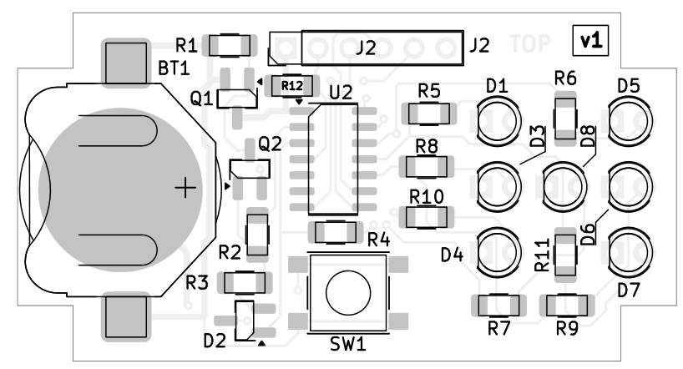

Schematic
